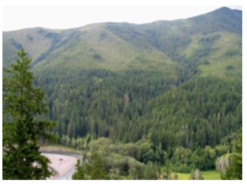
Elwha River Restoration
Aspect and Soil Moisture
Reflection Journal 1

What does moisture of soil have to do with the way trees grow?

What questions do you have about soil moisture?

Elwha River Restoration
Aspect and Soil Moisture
Vocabulary Notes

Aspect:

Snowpack:

Solstice:

Equinox:

Analemma:

Blackbody absorption:

Elwha River Restoration
Aspect and Soil Moisture
Reflection Journal 2

Why is soil moisture important to the structure of an ecosystem?

What questions do you have about the role soil moisture plays in an ecosystem?

